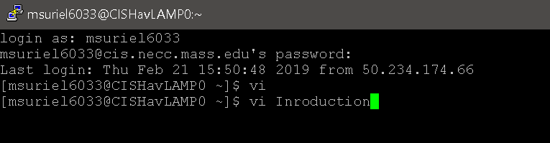

* Used the command vi to launch vi. Insert the text by copying then right clinking to paste in vi.
* Pressed the esc key followed by shift-:
* Named and exit the file with the command wq Introduction.
* Opened the file with the command vi Introduction.
* Added name and date to top.
* Pasted text using copy and insert the text by copying then right clinking to paste in vi.
* Used the command /(text) to find a word within the text.
* Then type n to find the next one.
* Saved and Exit file using the command wq.